Ex:No:02 BOOK BANK REGISTRATION SYSTEM

USE CASE DIAGRAM:
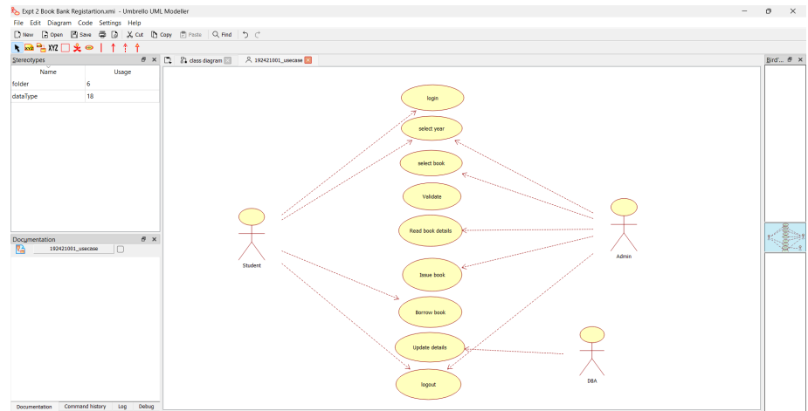

CLASS DIAGRAM
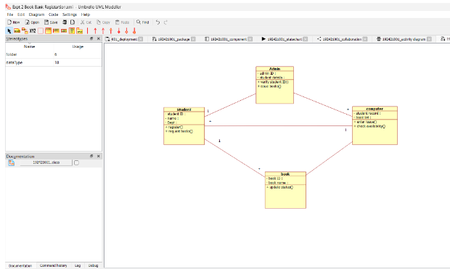

ACTIVITY DIAGRAM:
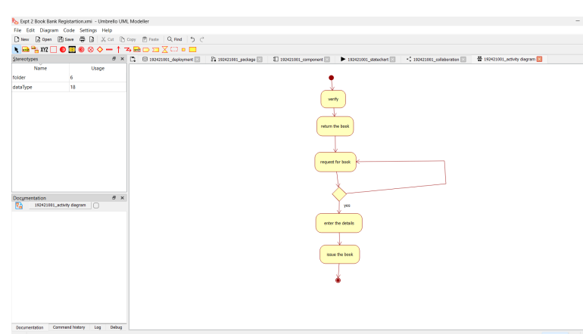

SEQUENCE DIAGRAM:

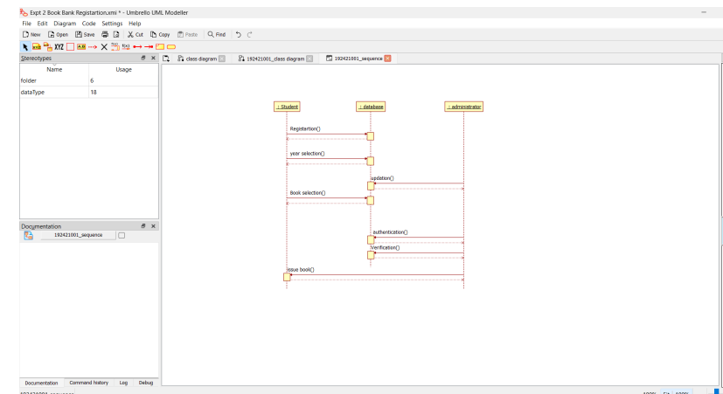

COLLABORATION DIAGRAM:
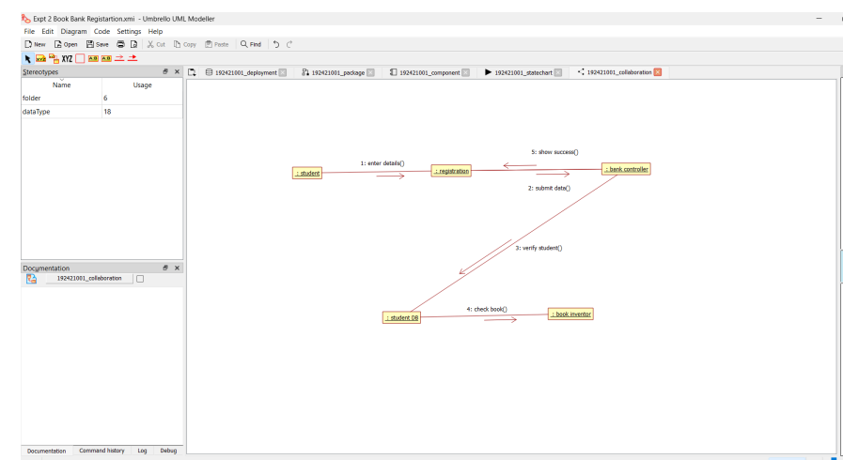

STATE CHART DIAGRAM
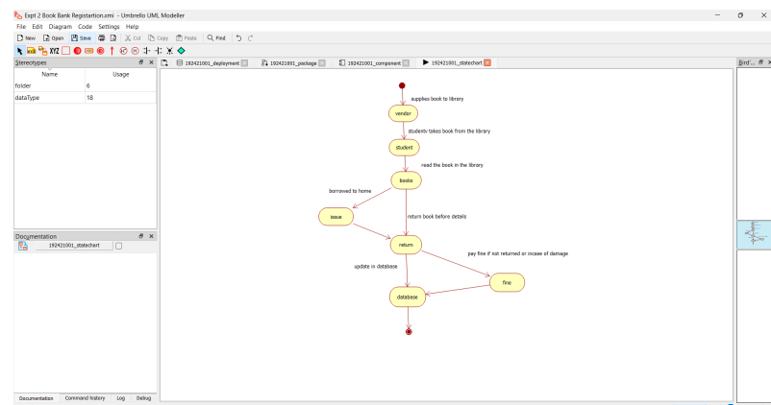

COMPONENT DIAGRAM
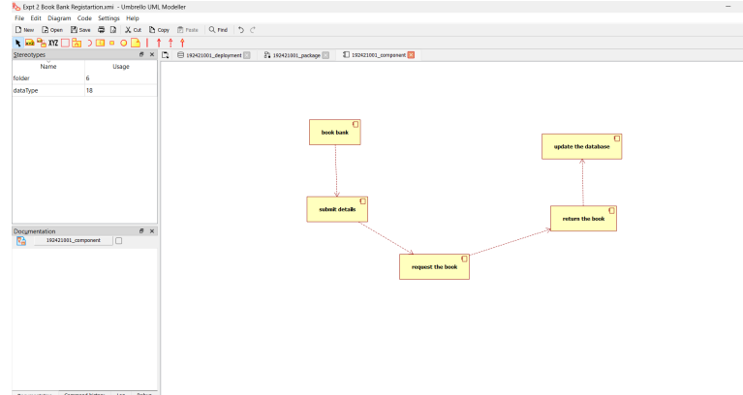

DEPLOYMENT DIAGRAM
